# **ActiveHouse**

Project website <https://irwintr.github.io>

Prepared by Trenton Irwin

## **Declaration of Sole Authorship**

I, Trenton Irwin, will be completing all of the work related to this project including the hardware, database, web service, and mobile application. Any uses made within it of the works of any other author, in any form (ideas, equations, figures, texts, tables, programs), are properly acknowledged at the point of use. A list of the references used is included. It is mandatory that all sources of information be acknowledged in the SRS. Plagiarism is unethical and a candidate suspected of plagiarizing may be referred to the Complaints Committee.

## **Proposal**

### **Proposal Table of Contents**

1. [Proposal](https://github.com/irwintr/irwintr.github.io/blob/master/README.md#proposal)
2. [Executive Summary](https://github.com/irwintr/irwintr.github.io/blob/master/README.md#executive-summary)
3. [Background](https://github.com/irwintr/irwintr.github.io/blob/master/README.md#background)
4. [Methodology](https://github.com/irwintr/irwintr.github.io/blob/master/README.md#methodology)
5. [Concluding Remarks](https://github.com/irwintr/irwintr.github.io/blob/master/README.md#concluding-remarks)
6. [References](https://github.com/irwintr/irwintr.github.io/blob/master/README.md#references)

The ActiveHouse Project would be a complete home monitoring system consisting of multiple Arduino based sensor hubs in each room of your home wirelessly connecting to a Raspberry Pi based base station which sends the data to the server where it can be read by the app. Each sensor hub would be capable of reading temperature, humidity, luminosity, carbon monoxide and other gas levels, water consumption, power consumption, and it would have the ability to toggle the built-in light. The power and water consumption sensors are detachable as they would not necessarily be used in each room, thus creating a more modular design. The app would allow users to view the current settings in each room and over the complete house, toggle the lighting, and set a lighting schedule.

## ### **Executive Summary**

As a Computer Engineering student, I’ll be using all of the skills I have learned in the last 2 years in this program to complete this project. This proposal requests the approval to build the hardware portion that will connect to a database as well as to a mobile device application. The sensor hub hardware will include a custom PCB with sensors and XBee wireless adapters and an Arduino inside a custom printed box. The Base station hardware will include an XBee wireless adapter connected to a Raspberry Pi. The database will store the sensor data from each room. The mobile device functionality will allow users to view the current settings in each room and over the complete house, toggle the lighting, and set a lighting schedule. I may end up collaborating with the greater Active House team later in the semester but I will not be working with any companies. The hardware will be completed in CENG 317 Hardware Production Techniques independently and the application will be completed in CENG 319 Software Project. These will be integrated together in the subsequent term in CENG 355 Computer Systems Project.

## ### **Background**

The problem solved by this project is that it provides a home monitoring solution so that users homes can be controlled and monitored remotely through an intuitive app. It will help people monitor their resource consumption as well which may help drive down consumption.

There are several other home monitoring solutions on the market now(Lien, Bai, & Lin, 2007), but they are usually integrated into either the thermostat or home security system. This is one of the first projects I’ve seen where water and power consumption are also monitored on a residential scale.

In the Computer Engineering Technology program I have learned about the following topics from the respective relevant courses:

* Electronic Devices and Circuits – Soldering experience
* Database with Java – Setting up database
* Electronic Circuits – Voltage Divider calculations
* Technical Workplace Writing – Creating write-ups and technical drawings
* Software Engineering – Creating project schedules

This knowledge and skill set will enable me to build the subsystems and integrate them together as my capstone project.

## ### **Methodology**

This proposal is assigned in the first week of class and is due at the beginning of class in the second week of the fall semester. My coursework will focus on the first two of the 3 phases of this project:  
Phase 1 Hardware build.  
Phase 2 System integration.  
Phase 3 Demonstration to future employers.

*Phase 1 Hardware build*

The hardware build will be completed in the fall term. It will fit within the CENG Project maximum dimensions of 12 13/16" x 6" x 2 7/8" (32.5cm x 15.25cm x 7.25cm) which represents the space below the tray in the parts kit. The highest AC voltage that will be used is 16Vrms from a wall adaptor from which +/- 15V or as high as 45 VDC can be obtained. Maximum power consumption will be 20 Watts.

*Phase 2 System integration*

The system integration will be completed in the winter term.

*Phase 3 Demonstration to future employers*

This project will showcase the knowledge and skills that we have learned to potential employers.

The tables below provide rough effort and non-labour estimates respectively for each phase. A Gantt chart will be added by week 3 to provide more project schedule details and a more complete budget will be added by week 4. It is important to start tasks as soon as possible to be able to meet deadlines.

|  |  |  |
| --- | --- | --- |
| **Labour Estimates** | **Hrs** | **Notes** |
| **Phase 1** |  |  |
| Writing proposal. | 9 | Tech identification quiz. |
| Creating project schedule. Initial project team meeting. | 9 | Proposal due. |
| Creating budget. Status Meeting. | 9 | Project Schedule due. |
| Acquiring components and writing progress report. | 9 | Budget due. |
| Mechanical assembly and writing progress report. Status Meeting. | 9 | Progress Report due (components acquired milestone). |
| PCB fabrication. | 9 | Progress Report due (Mechanical Assembly milestone). |
| Interface wiring, Placard design, Status Meeting. | 9 | PCB Due (power up milestone). |
| Preparing for demonstration. | 9 | Placard due. |
| Writing progress report and demonstrating project. | 9 | Progress Report due (Demonstrations at Open House Saturday, November 7, 2015 from 10 a.m. - 2 p.m.). |
| Editing build video. | 9 | Peer grading of demonstrations due. |
| Incorporation of feedback from demonstration and writing progress report. Status Meeting. | 9 | 30 second build video due. |
| Practice presentations | 9 | Progress Report due. |
| 1st round of Presentations, Collaborators present. | 9 | Presentation PowerPoint file due. |
| 2nd round of Presentations | 9 | Build instructions up due. |
| Project videos, Status Meeting. | 9 | 30 second script due. |
| **Phase 1 Total** | **135** |  |
| **Phase 2** |  |  |
| Meet with collaborators | 9 | Status Meeting |
| Initial integration. | 9 | Progress Report |
| Meet with collaborators | 9 | Status Meeting |
| Testing. | 9 | Progress Report |
| Meet with collaborators | 9 | Status Meeting |
| Meet with collaborators | 9 | Status Meeting |
| Incorporation of feedback. | 9 | Progress Report |
| Meet with collaborators | 9 | Status Meeting |
| Testing. | 9 | Progress Report |
| Meet with collaborators | 9 | Status Meeting |
| Prepare for demonstration. | 9 | Progress Report |
| Complete presentation. | 9 | Demonstration at Open House Saturday, April 9, 2016 10 a.m. to 2 p.m. |
| Complete final report. 1st round of Presentations. | 9 | Presentation PowerPoint file due. |
| Write video script. 2nd round of Presentations, delivery of project. | 9 | Final written report including final budget and record of expenditures, covering both this semester and the previous semester. |
| Project videos. | 9 | Video script due |
| **Phase 2 Total** | **135** |  |
| **Phase 3** |  |  |
| Interviews | TBD |  |
| **Phase 3 Total** | **TBD** |  |
| **Material Estimates** | **Cost** | **Supplier** |
| **Phase 1** |  |  |
| Cannakit Raspberry Pi v3 | $99.99 | Amazon.ca |
| Arduino Uno SMD Rev3 | $31.08 | Digi-key |
| Xbee S1 Trace Antenna (x2) | $53.68 | Digi-key |
| Xbee Shield for Arduino | $22.77 | Digi-key |
| 3.5mm audio jack | $2.09 | Canada Robotix |
| Non-Invasive Current Sensor | $13.19 | Canada Robotix |
| Adafruit Gas Sensor | $21.12 | Digi-key |
| Adafruit Light Sensor | $8.40 | Digi-key |
| Water Flow Sensor | $11.89 | Canada Robotix |
| 3 Pin Molex header | $0.39 | Canada Robotix |
| 12mm Buzzer | $1.99 | Canada Robotix |
| Adafruit Temperature and Humidity Sensor | $19.70 | Digi-key |
| *Shipping* | *$6.95* |  |
| *Tax* | *$37.22* |  |
| **Phase 1 Total** | **$330.46** |  |
| **Phase 2** |  |  |
| Materials to improve functionality, fit, and finish of project. | N/A |  |
| **Phase 2 Total** | **TBD** |  |
| **Phase 3** |  |  |
| **Phase 3 Total** | **TBD** |  |

## ### **Concluding remarks**

This proposal presents a plan for providing an IoT solution for a home monitoring system. This is an opportunity to integrate the knowledge and skills developed in the Computer Engineering program to create a collaborative IoT capstone project demonstrating my ability to learn how to support projects. I request approval of this project.

## **Abstract**

This report contains information outlining the ActiveHouse home monitoring system project. The project aims to create a complete home enviromental monitoring system to measure temperature, humidity, light levels, water consumption, power consumption, smoke and gas detection, and the ability to toggle lights. There is an Android mobile application for displaying the data and making changes. The hardware consists of a Raspberry Pi, an Arduino, xBee wireless adapters, and a mirriad of sensors. The web service and database to store all the data is hosted on Munro.humber.ca. The total cost for the prototype is about $330. The project will take me about 8 months to complete but can be redone in much less time.

## **Table of Contents**

1. [Declaration of Sole Authorship](https://github.com/irwintr/irwintr.github.io/blob/master/README.md#declaration-of-sole-authorship)
2. [Proposal](https://github.com/irwintr/irwintr.github.io/blob/master/README.md#proposal)
3. [Abstract](https://github.com/irwintr/irwintr.github.io/blob/master/README.md#abstract)
4. [Table of Contents](https://github.com/irwintr/irwintr.github.io/blob/master/README.md#table-of-contents)
5. [List of Illustrations or Diagrams](https://github.com/irwintr/irwintr.github.io/blob/master/README.md#list-of-illustrations-or-diagrams)
6. [Introduction](https://github.com/irwintr/irwintr.github.io/blob/master/README.md#introduction)
7. [Project Description](https://github.com/irwintr/irwintr.github.io/blob/master/README.md#project-description)
8. [Conclusion](https://github.com/irwintr/irwintr.github.io/blob/master/README.md#conclusion)
9. [Appendicies](https://github.com/irwintr/irwintr.github.io/blob/master/README.md#appendicies)
10. [Bibliography](https://github.com/irwintr/irwintr.github.io/blob/master/README.md#bibliography)

## **List of Illustrations or Diagrams**

## **Introduction**

The ActiveHouse Project is a complete home monitoring system consisting of multiple Arduino based sensor hubs in each room of your home wirelessly connecting to a Raspberry Pi based base station which sends the data to the server where it can be read by the app. Each sensor hub is be capable of reading temperature, humidity, luminosity, carbon monoxide and other gas levels, water consumption, power consumption, and it would have the ability to toggle the built-in light. The power and water consumption sensors are detachable as they would not necessarily be used in each room, thus creating a more modular design. The app allows users to view the current settings in each room and over the complete house, toggle the lighting, and set a lighting schedule.

## **Project Description**

### Database Specifications

**Database Type**

For the ActiveHouse project I am using a MySQL database hosted on Munro. It can be administered through phpMyAdmin.

**Database Tables**

There are four tables that are used in the Firebase.

1. USERS
2. HOUSE
3. ROOM
4. ROOM_DATA

**USERS** is the table in which all users who sign up for the ActiveHouse application are stored. They are given a key as a unique identifier.

**HOUSE** is the table in which the names of houses and their data are stored. Each house is unique via an HOUSEID identification key within the table.

**ROOM** is the table in which the rooms in each house are stored. It contains the HOUSEID that it corresponds with, a unique ROOMID and the room name.

**ROOM_DATA** is the table where the sensor readings for each room are stored. It is identified by the unique ROOMID.

**Work Breakdown**

There is no further work that needs to be done to the database.

### **Mobile Application Specifications**

**Graphical User Interface Specifications**

**MainActivity:** The login screen of the application is the first presented upon launching the application. The user may enter already existing credentials into EditText fields and login, or may choose to go to the sign up activity, both navigations via Buttons. There is a checkbox to save the entered username to local storage to be auto populated in future sessions.

**RegisterActivity:** The sign up screen of the application can be accessed from the login screen. It has EditText fields for gathering new user information including their HOUSEID. Without a HOUSEID, they cannot create a new account. Incorrect EditText entries will be communicated via Toast message asking for re-entry.

**HomeActivity:** This is the main screen of the app where the user can view the current settings of the user’s house. There is a hamburger menu with links to the other pages including one for each room in the home. Users can logout from the menu bar.

**RoomActivity:** This page has the sensor data from an individual room displayed. The user can interact with the page by toggling the light or light schedule or setting the time on or off for the light. There is a hamburger menu with links to the other pages including one for each room in the home. Users can logout from the menu bar.

**RoomViewActivity:** The room view activity is a listview with all of the rooms in it. Users can select the room they wish to view and be taken to the RoomActivity page for that room.

**Application Work Breakdown**

There are a few small bugs that I need to patch, but the app is working and pretty much complete.

### **Web Specifications**

**Web Service Specifications**

The web service is written in php and hosted on Munro. It can be accessed at munro.humber.ca/~n01046059/ActiveHouse.

**Web Work Breakdown**

The side of the web service that interacts with the mobile app is complete and does not require any changes. I do need to write the side of the web service that connects to the Raspberry Pi to send and receive sensor data. Additionally I need to write a program to run on the Raspberry Pi to send the data to the server.

### **Build Instructions**

My Active House project is a complete home monitoring system. The idea is that you would have one Sensor Hub in each room of your home to collect data You would have one Raspberry Pi based base station which all of the sensor hubs send their data wirelessly to. The base station then sends the received sensor data to the database for use in my app.



#### Parts:

Here is a list of all the parts and aproximate costs for one Raspberry Pi base station and one Sensor Hub:

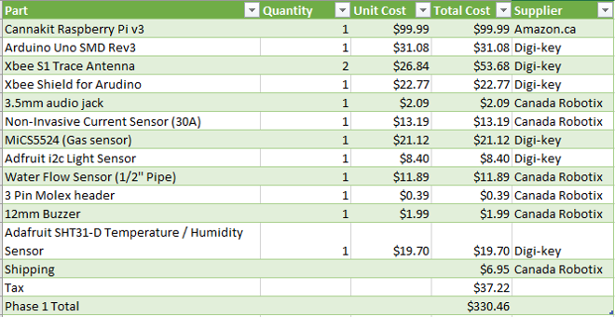

This list does not include parts from the Humber electronics parts kit. The parts you will need from the kit are:

* 220ohm Resistor
* 33ohm Resistor
* 2x 10Kohm Resistors
* LED
* 50uf Capacitor
* Single Core Wire

You will also need to print out the Acrylic case which can be found [here](https://github.com/irwintr/irwintr.github.io/tree/master/Case) and the 2 PCBs which can be found [here](https://github.com/irwintr/irwintr.github.io/tree/master/ArdunioShield) and [here](https://github.com/irwintr/irwintr.github.io/tree/master/XBeeBreakout).

#### Time Commitment

While it took me probably upwards of 30 hours to design the project and the circuit boards, put it all together, and code it, I'd expect it to only take around 5 hours to build the project again.

#### PCB/Soldering

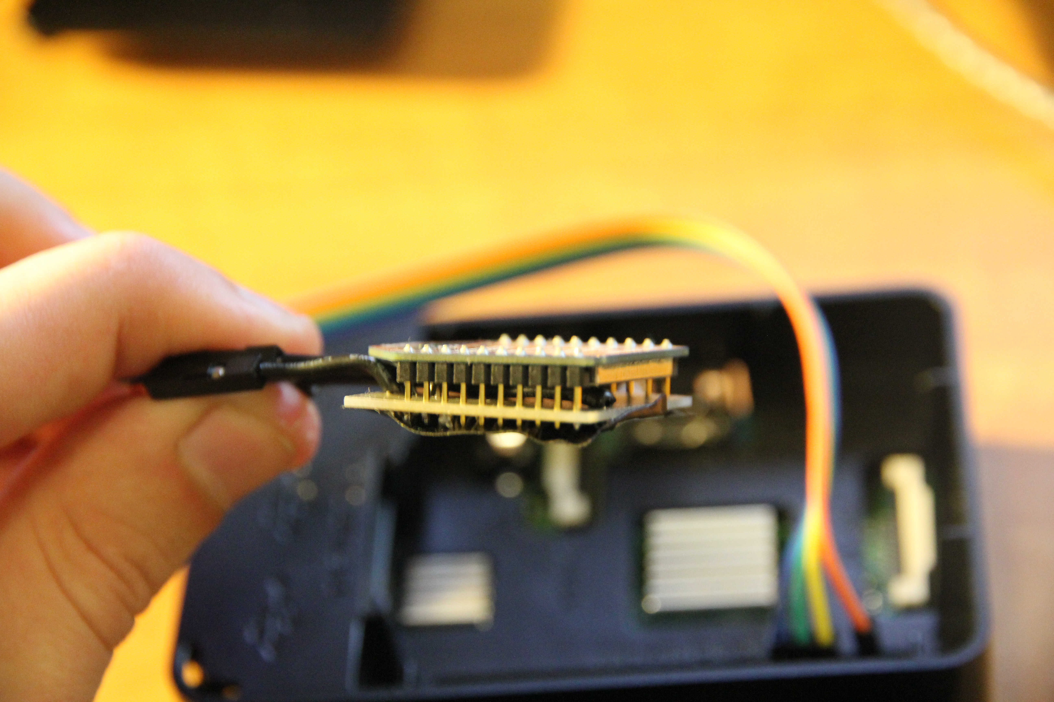

The first board you will need to solder is the XBee Breakout board. You only need to solder the 3.3v, GND, RX and TX pins as seen in this diagram:

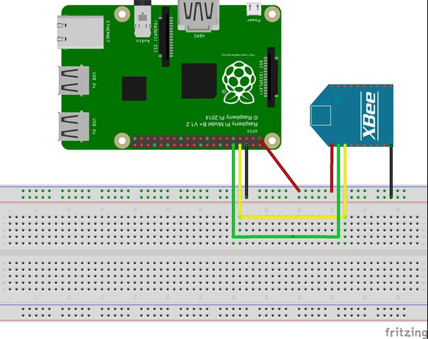

Then you will need to solder the Arduino Shield which includes all of the sensors and connections. You can view the board and schematic files for this board [here](https://github.com/irwintr/irwintr.github.io/tree/master/ArdunioShield) which will explain where all of the components and connections go. Beware, some of the solder pads on the Arduin Shield are very small and you will need a very steady hand to solder them. Below are a collection of images which will help you understand where everything goes and how it is connected:

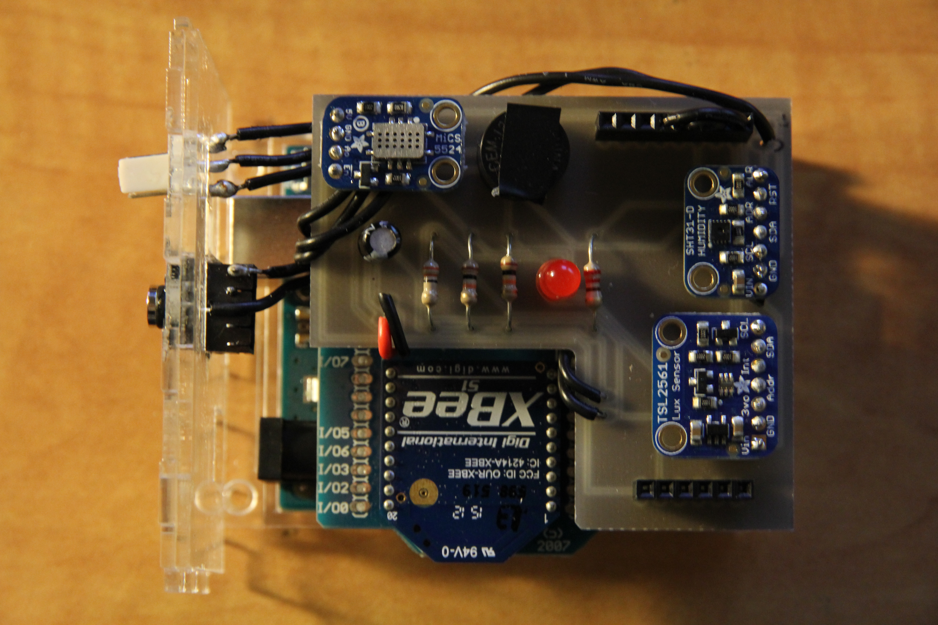

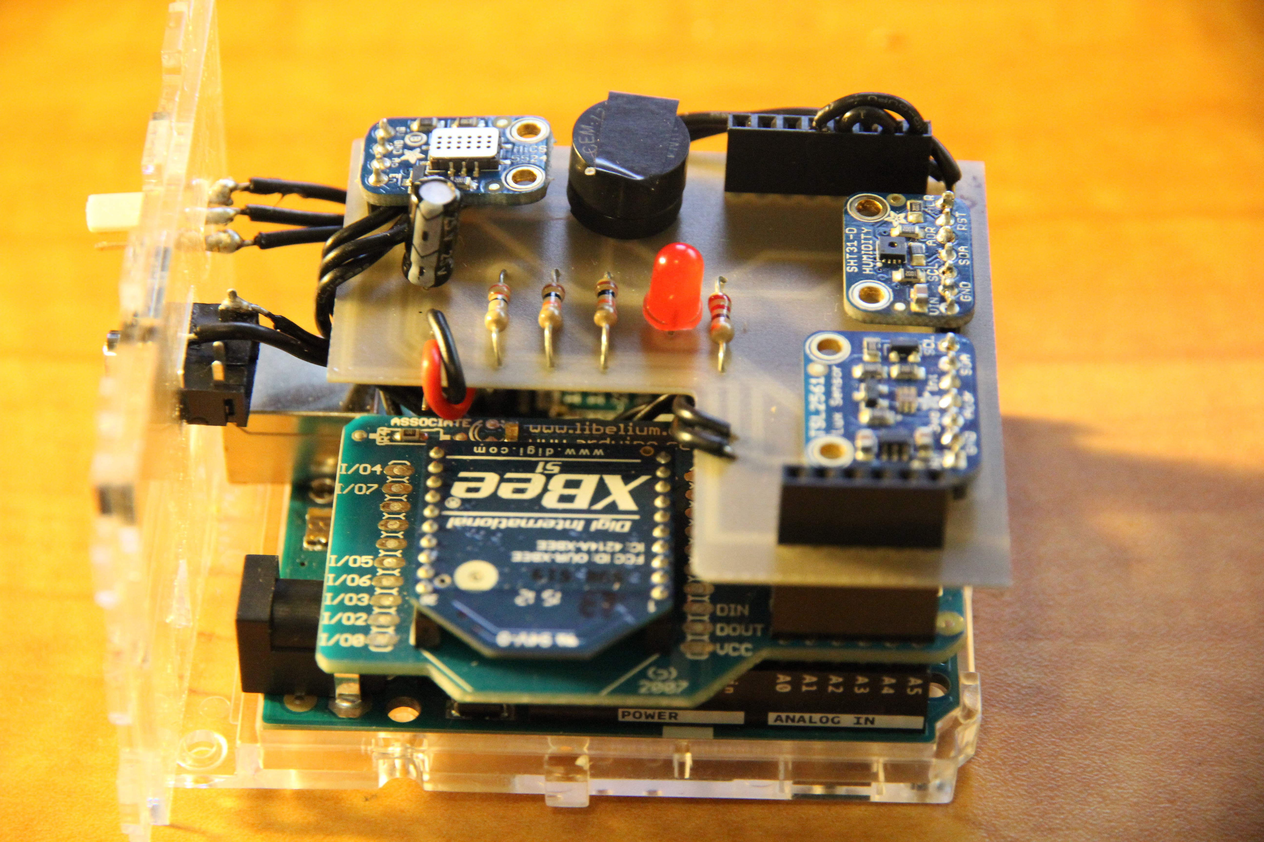

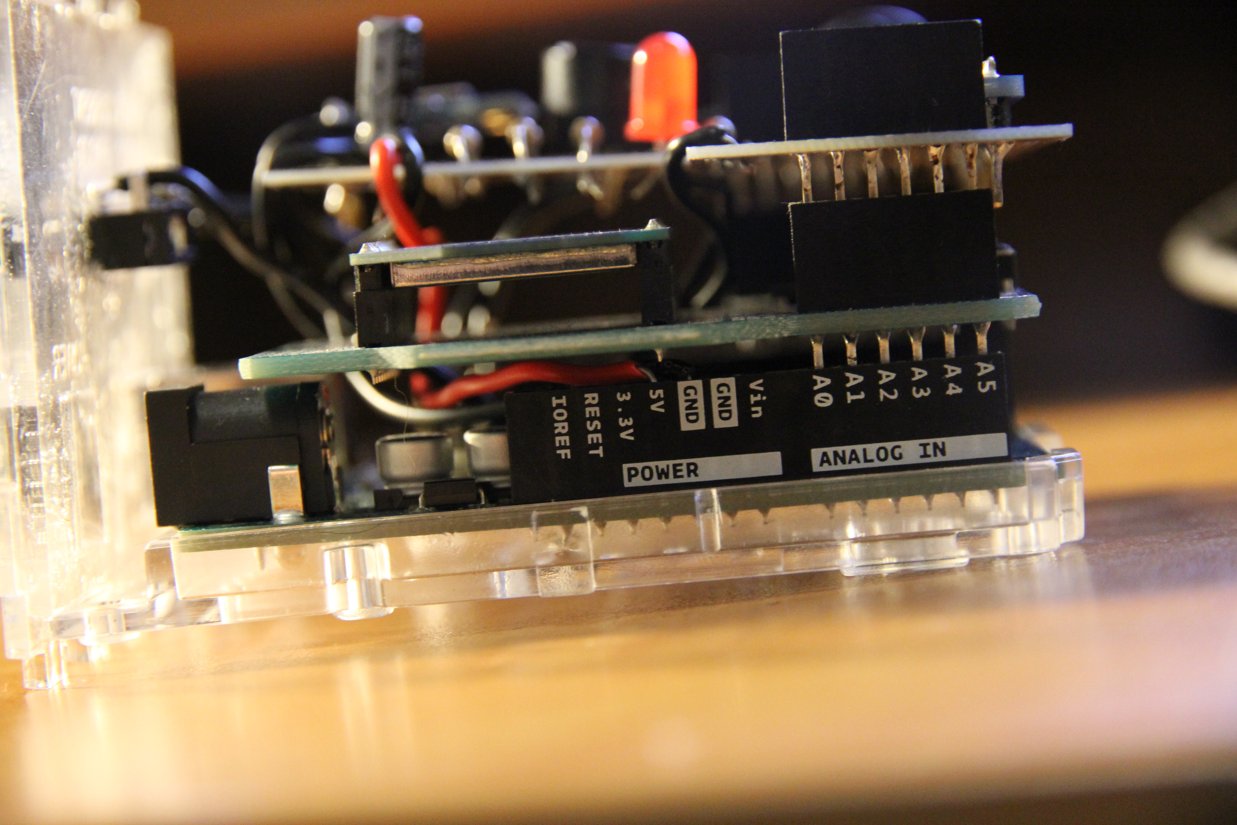

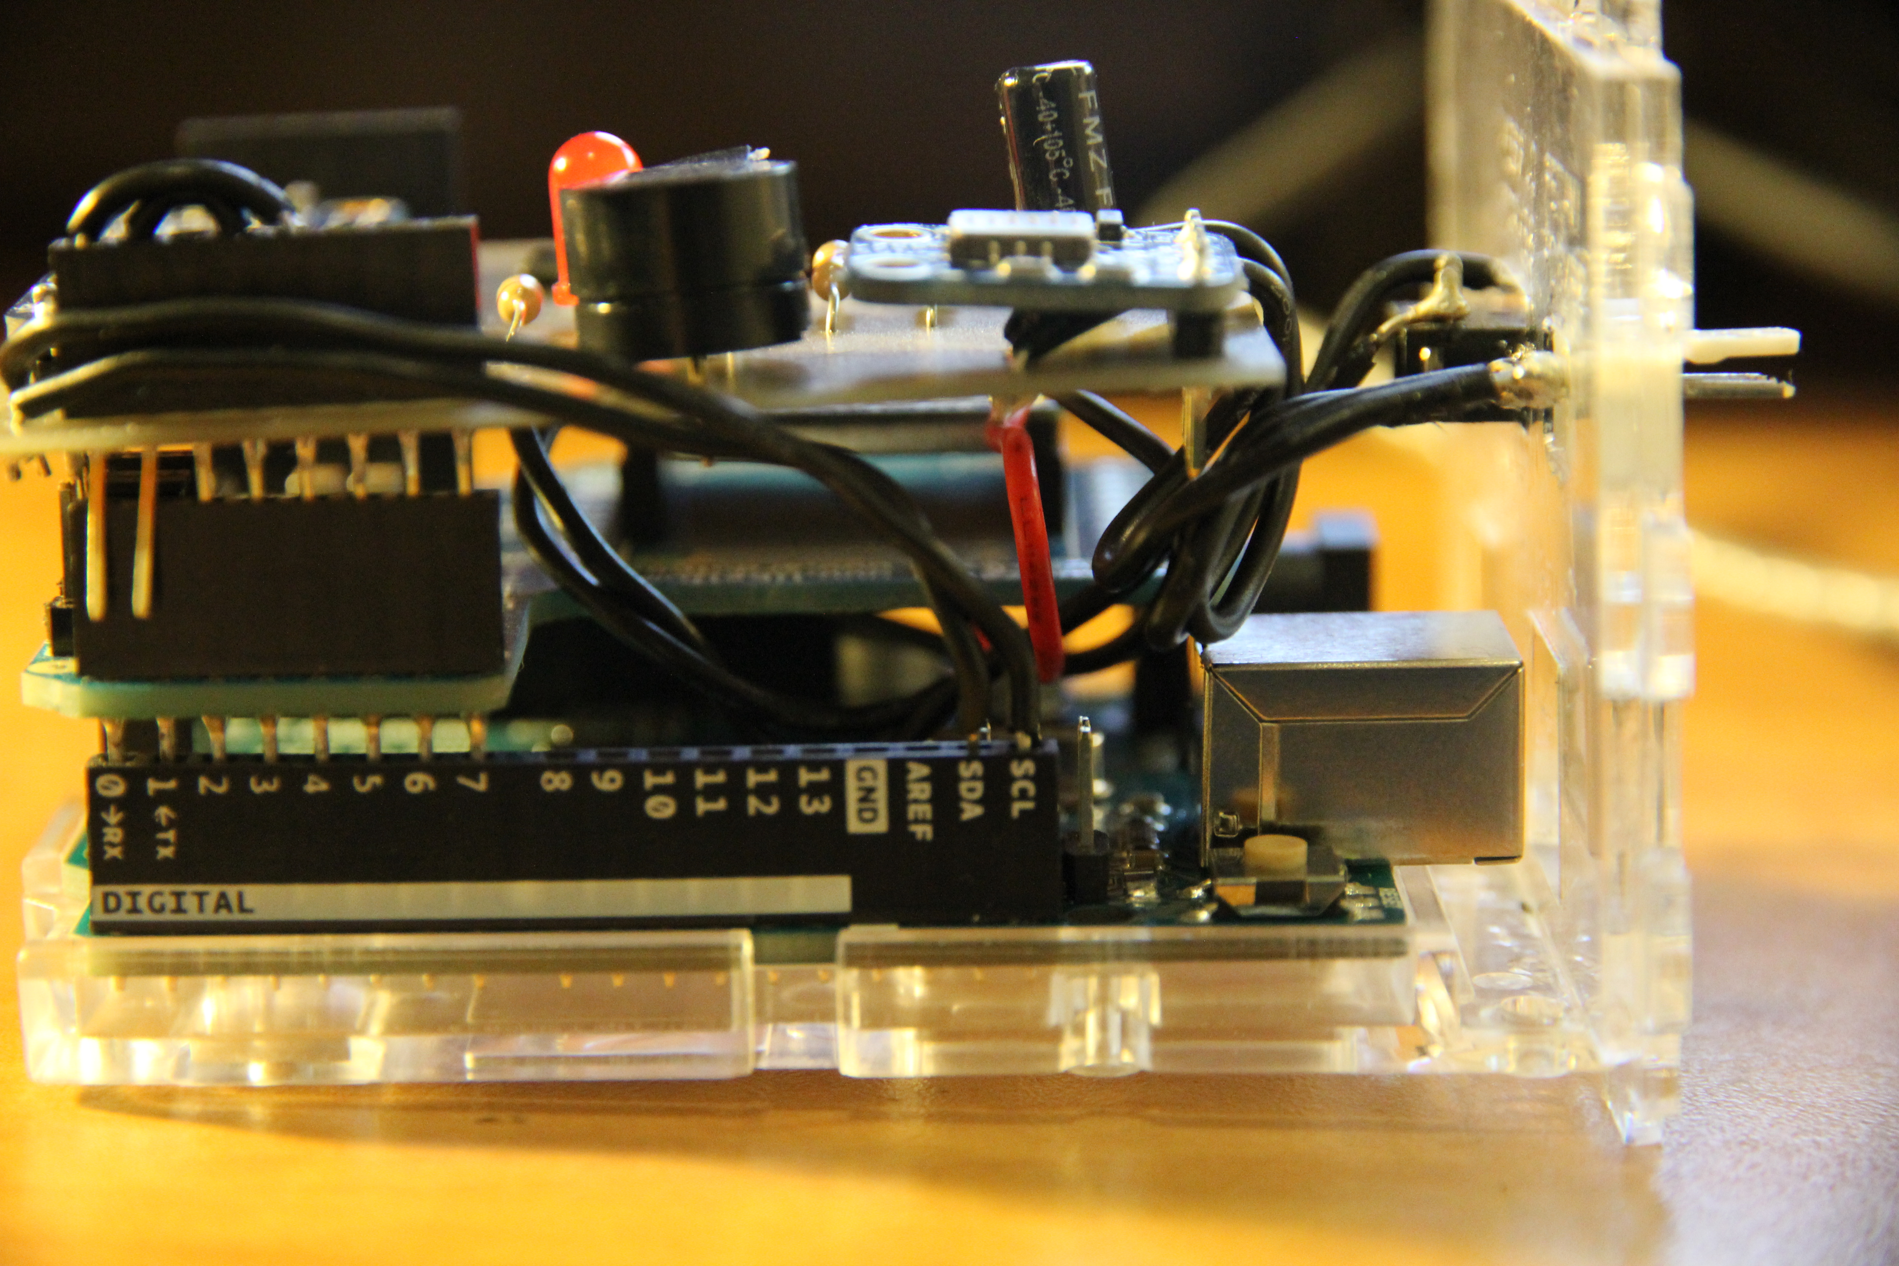

#### Mechanical Assembly

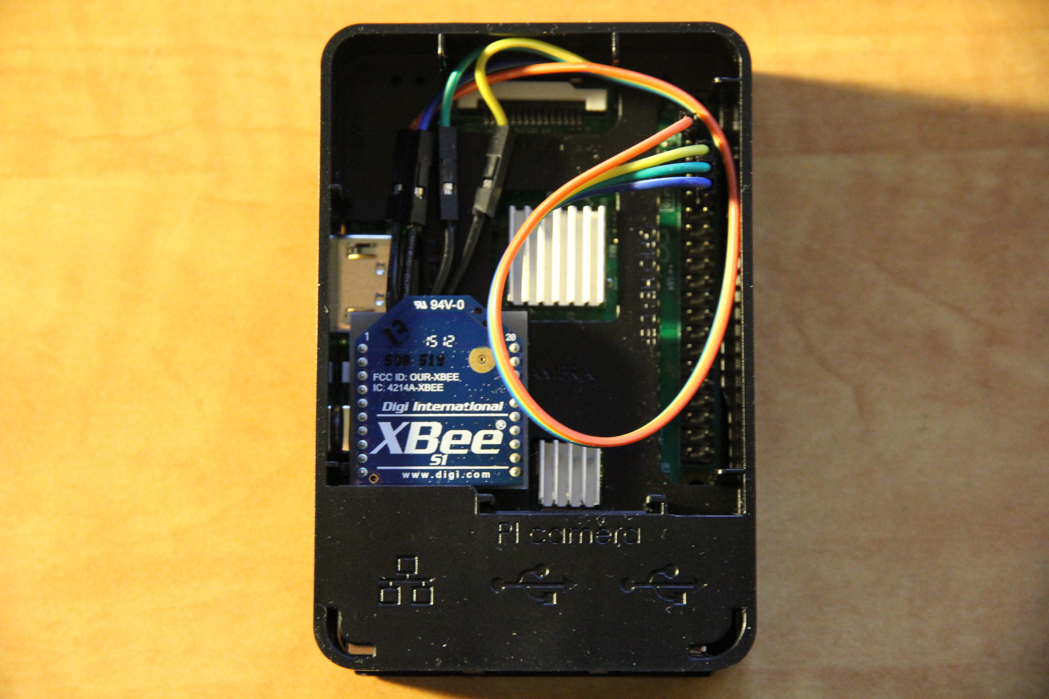

First, you will need to unbox your Raspberry Pi and set it up. You can view my unboxing video here. After that, connect the wires from the Xbee breakout board to the appropriate GPIO pins.

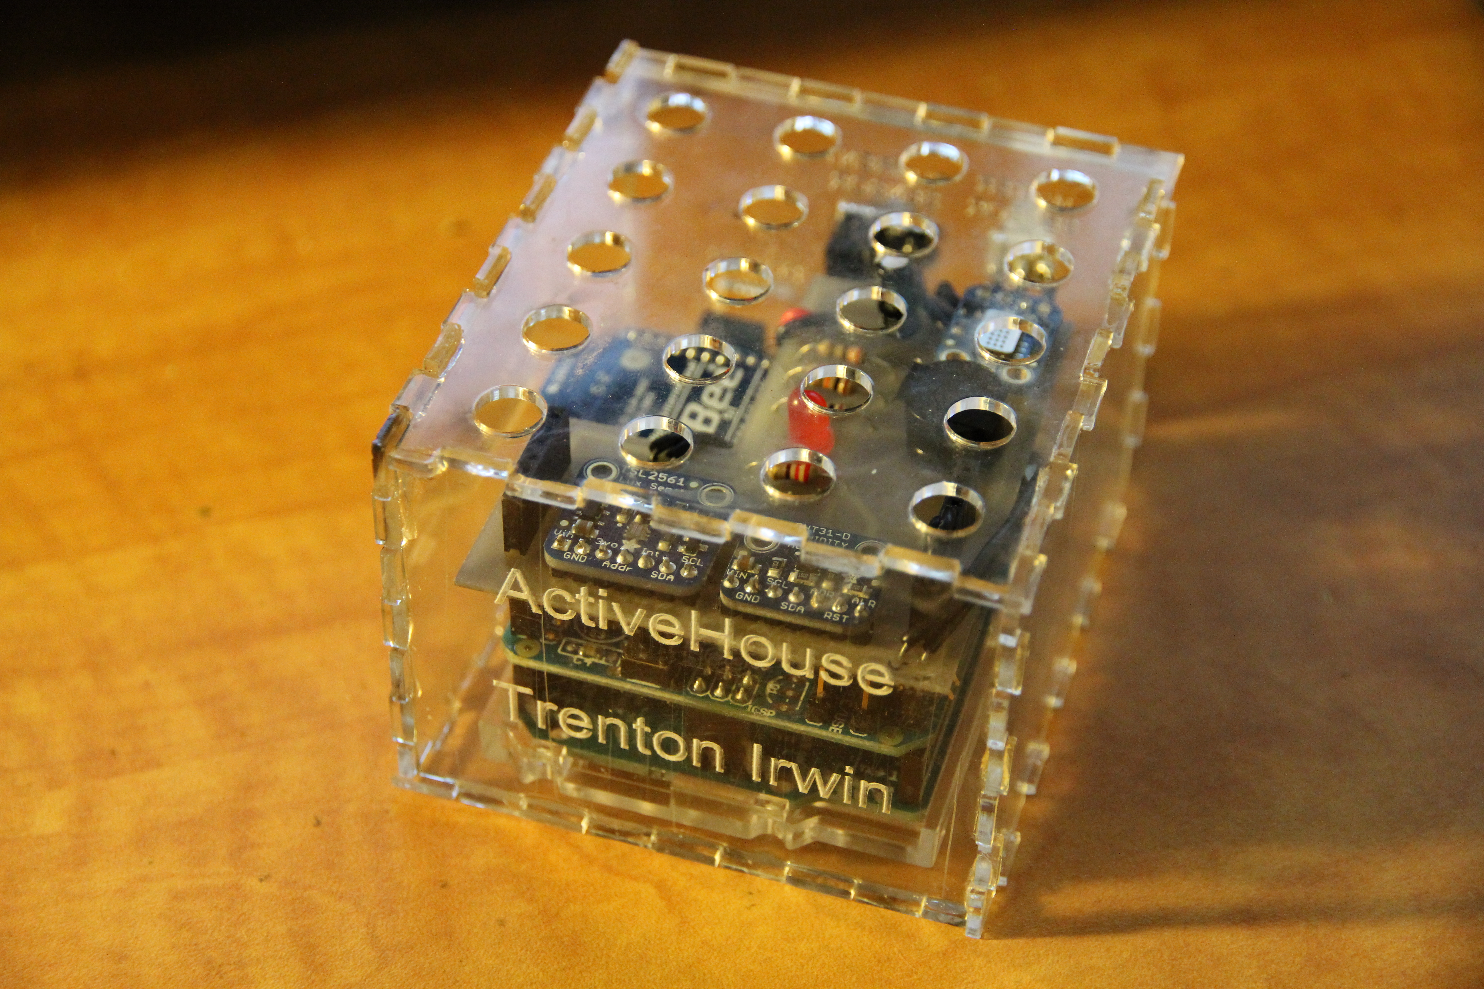

Next you will need to build your acrylic case for your Arduino. Glue the all but the back side together and glue the ports for the current and liquid sensors onto the rear panel of the case.

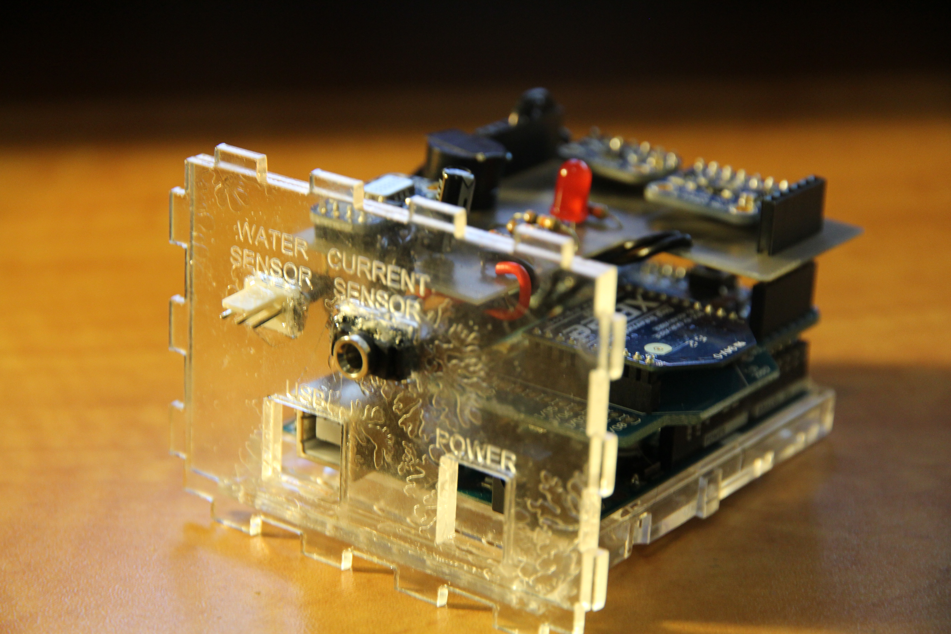

#### Code

You can view the Arduino Code [here](https://github.com/irwintr/irwintr.github.io/tree/master/ArduinoCode) to read all of the sensor data and output it to Serial. You will also need to include the Libraries folder. Due to a limitation with the Arduino Uno and the Arduino XBee Shield, you cannot upload code to the Arduino while the XBee shield is plugged in, so it needs to be removed from the arduino board when uploading. Alternativly, you could flash the Arduino Uno's bootloader with the Duemilanove which supports uploading code over XBee and send the code to the Arduino wirelessly from the Raspberry Pi. You can read about how to flash the bootloader [here](https://learn.sparkfun.com/tutorials/installing-an-arduino-bootloader)

#### Power Up

The output from the Arduino is below. You can also view my power up in my Build Video.

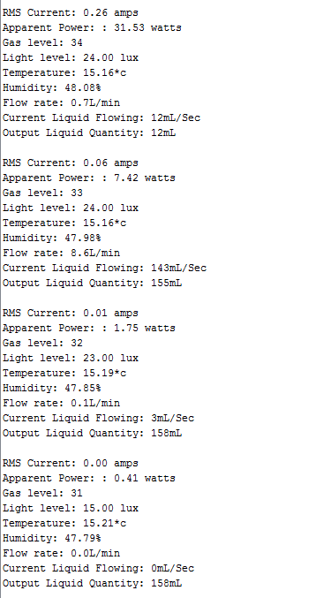

#### Testing

In all of the testing I have done so far, everything works as expected. I've checked the read values from the temperature, humidity, light, and gas sensors and they all seem to be accurate. I have noth been able to find a 1/2" hose to connect to my liquid flow sensor so I've been unable to calibrate it, but tripping it by blowing air trough it works as expected. I've tested the current sensor with a few different appliances and its's read values seem to be close to the expected range, howeer I still need to completely calibrate it with an clampmeter. The buzzer and LED can both be toggled from within the code.

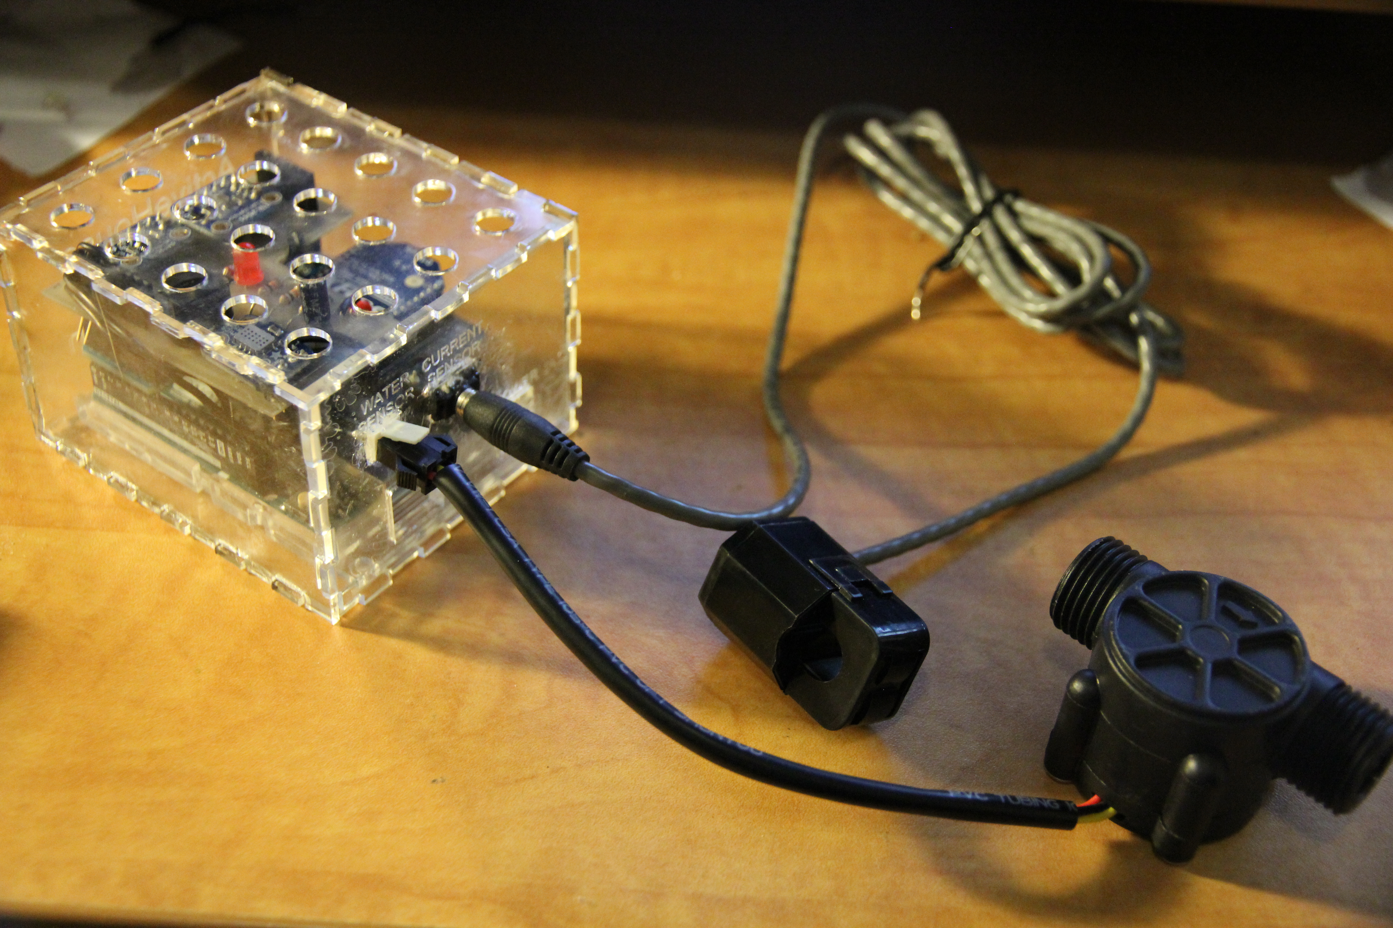

## **Conclusions**

 The ActiveHouse project is nearly complete and will be within the next week. It was definately a learning experience, but I fell like it was a sucessful project. There are a few things I might do differently next time including adding a Sync button to both the base station and the sensor boxes to pair them automatically, however my current method of pairing works just fine. All of the components of the project are working flawlessly together as expected, there is just a bit of coding left to be done. The ActiveHouse project has great potential as a home monitoring system as it has many features included such as water and power consumption monitoring that aren't included in commercial solutions that are currently on the market. Unfortunately, the fact that it's build using mainly consumer hardware such as the Raspberry Pi and the Arduino makes it not financially viable to birng to market without compltetely rebuilding it all using cheaper microcontrollers. It was still a very good learning experience and the skills that I have learned on this project will keep me tinkering with electronics for years to come.

## **Appendicies**

## **Bibliography**

Lien, C. h., Bai, Y. w., & Lin, M. b. (2007). Remote-controllable power outlet system for home power management. *IEEE Transactions on Consumer Electronics*, *53*(4), 1634–1641. <https://doi.org/10.1109/TCE.2007.4429263>